**10 dB COUPLER**

Frequency 1.6-3.2 GHz

1. Make the substrate: L = 82mm, Height of substrate (H_ERR) = 0.787mm; Substrate material (FR-4)

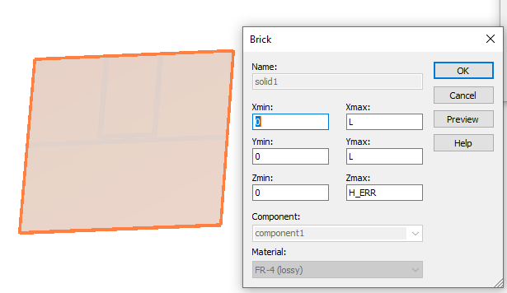

2. Make a Transmission line micro strip of width (W_WIDTH) = 2.3mm; and Micro strip thickness t = 0.035mm; L=82mm

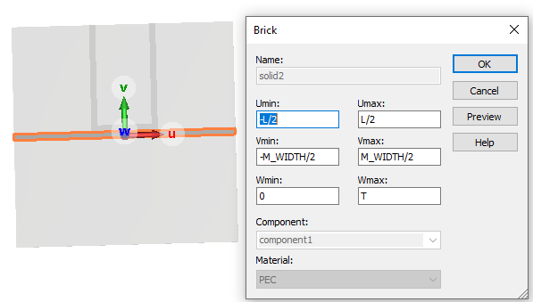

3. Make a micro strip of width 2.3mmt thickness t= 0.035mm; L = 24.6mm

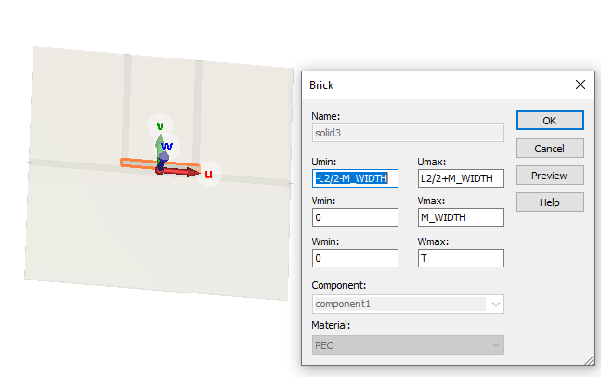

4. Make two transmission lines micro strips at the edges of the small micro strip. Length = 37.345190mm, t= 0.035mm; width =2.3mm

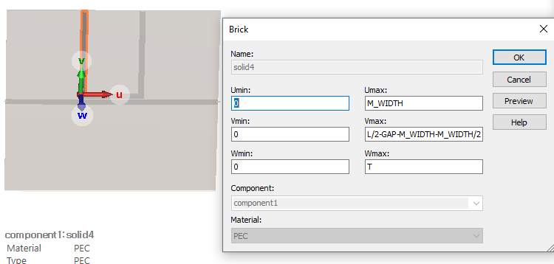

Results:

**10 dB Coupler**

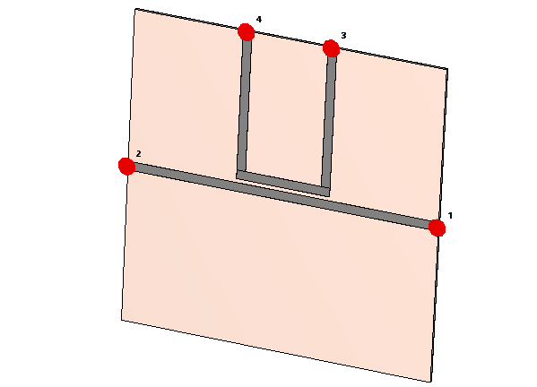 C:\Users\nyamba\Desktop\10db.emf

|  |  |  |  |  |  |  |  |  |
| --- | --- | --- | --- | --- | --- | --- | --- | --- |
| **Parameter** | *L*­1(mm) | *L*­2 (mm) | *L*­3 (mm) | *Gap* (mm) | *Er* | *Tan d* | *Mw* | *H* |
| **Value** | 82 | 38.85 | 20 | 0.2048 | 2.5 | 0.002 | 2.3 | 0.787 |

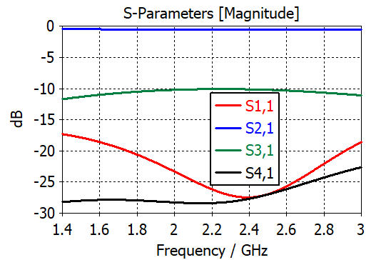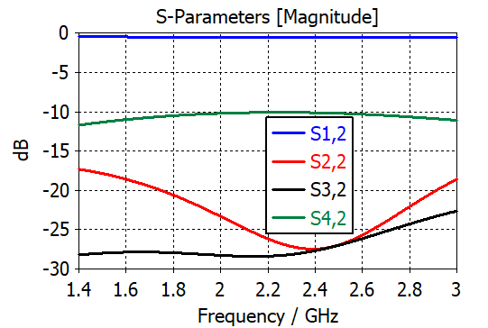

Fig. 1 Fig. 2

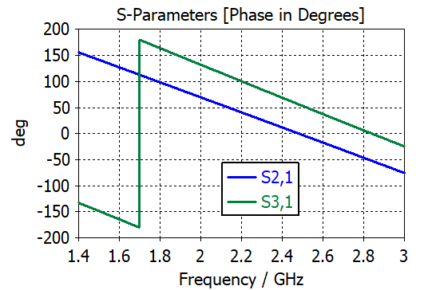 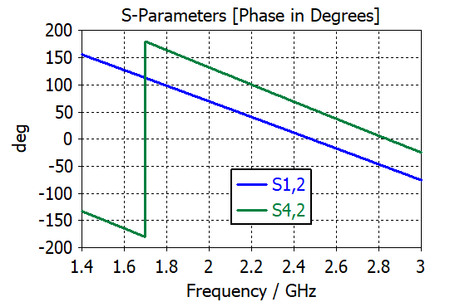

Fig. 3 Fig. 4